Use Case Diagram Case Study

Case 1:

The customer inserts his credit card into the machine. The machine requests the user PIN. The system validates the PIN. If the validation is successful, the customer can choose the withdraw operation. The customer enters the amount of cash to withdraw. The system checks the amount of cash in the user account. If the withdraw amount is between the current amount and credit limit, the machine dispenses the cash, prints a withdraw receipt and ejects the card.
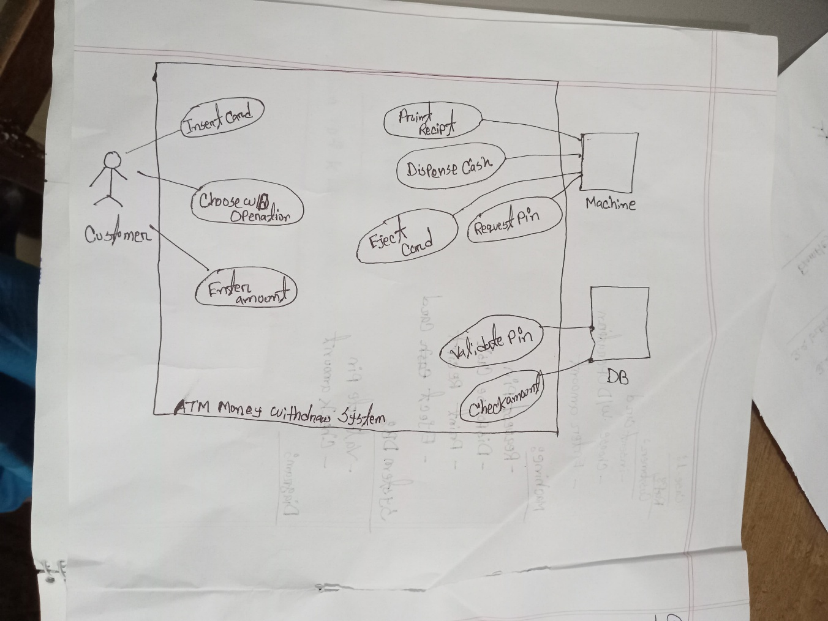

Case 2:

In a hotel management system, a guest can rent rooms. Hotel receptionist assists in the renting. A guest can also book a room for the future, with the help of the receptionist, as he has to check if the room has prior booking or not. A Guest pays for the rooms when they check out. He can pay by cash, check or credit card. Receptionists have to login to the system before using it, but to login he has go through username/password verification.
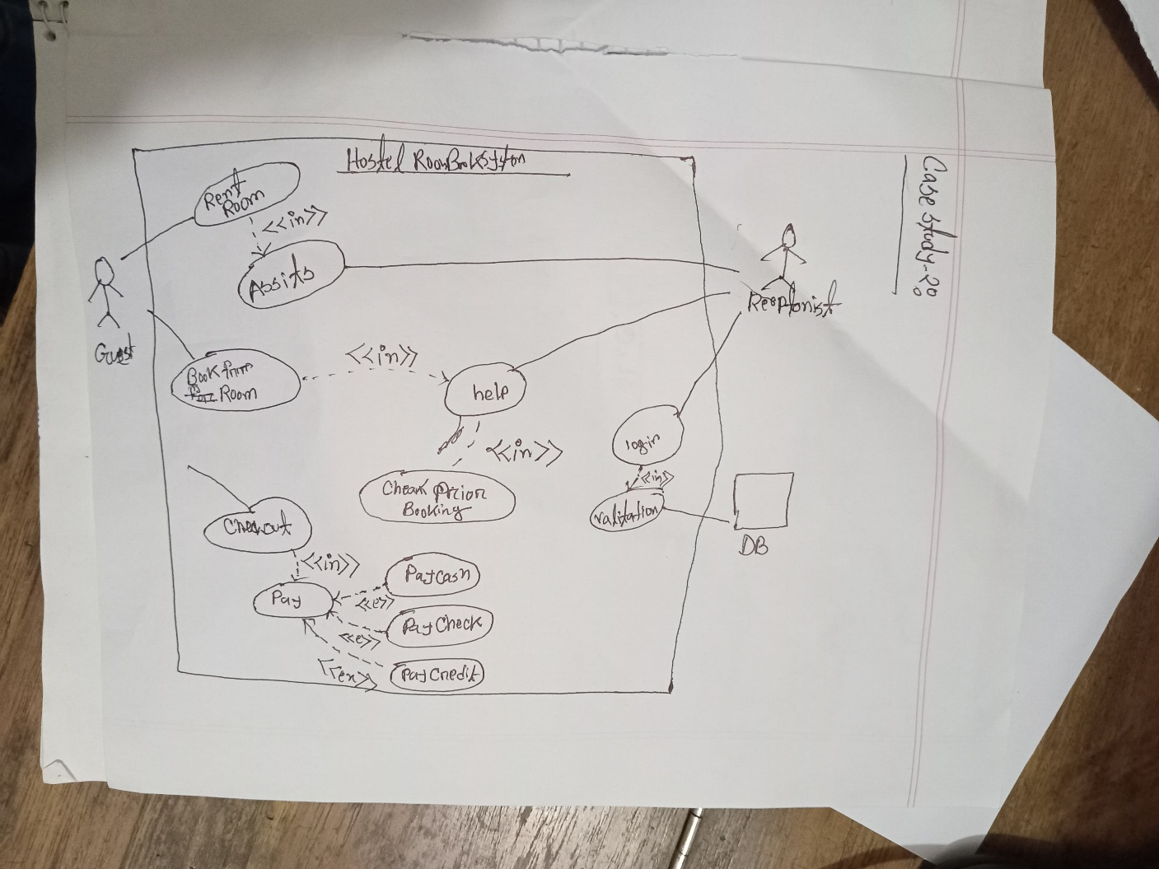

Case 3:

In a hospital management system, a patient's medical history is created by a doctor. The doctor may refer the patient to get admitted. A patient can rent hospital facilities like rooms, beds or ICUs based on the referral. The system automatically checks the referral before he can rent any hospital facility. Admitted patients are regularly visited by doctors and a nurse updates patient medical history after each visit. While updating the medical history, the nurse writes either the doctor's visit information or prescribed medication or test. The nurse also updates the medical history when the doctor writes the discharge note of the patient when he leaves. An account clerk prepares the bill. The bill is calculated from the elements written in medical history, i.e. number of doctor's visits, prescribed medication, tests. The patient may pay by cash or card when the bill is prepared.
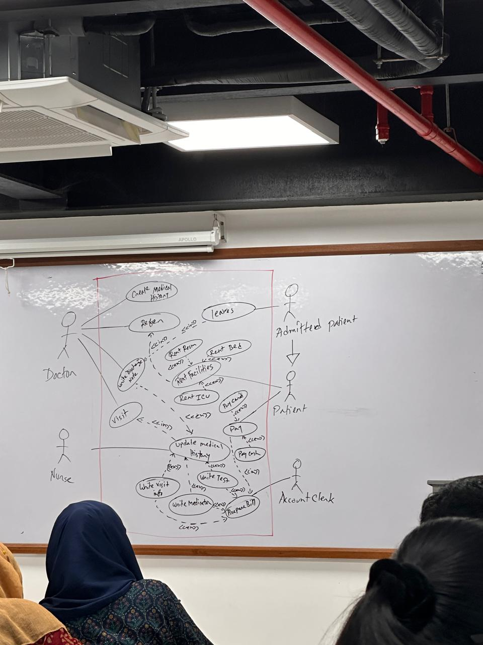

Case 4:

Music Today is an audio recording company. There are several recordists in the company. Clients record their music with the help of the recordists. The recording is done in a session. A session is usually created by the office clerk. A session needs to be booked by the client beforehand and before booking the time needs to be verified by the booking clerk for availability. The company maintains a list of preferred clients who book sessions like regular clients but also can create sessions according to their needs. Clerks have to log in to use the system. Clients can pay in cash or card. The accountant deals with the payment. The payment is only cleared when the accountant receives clearance from the booking clerk.
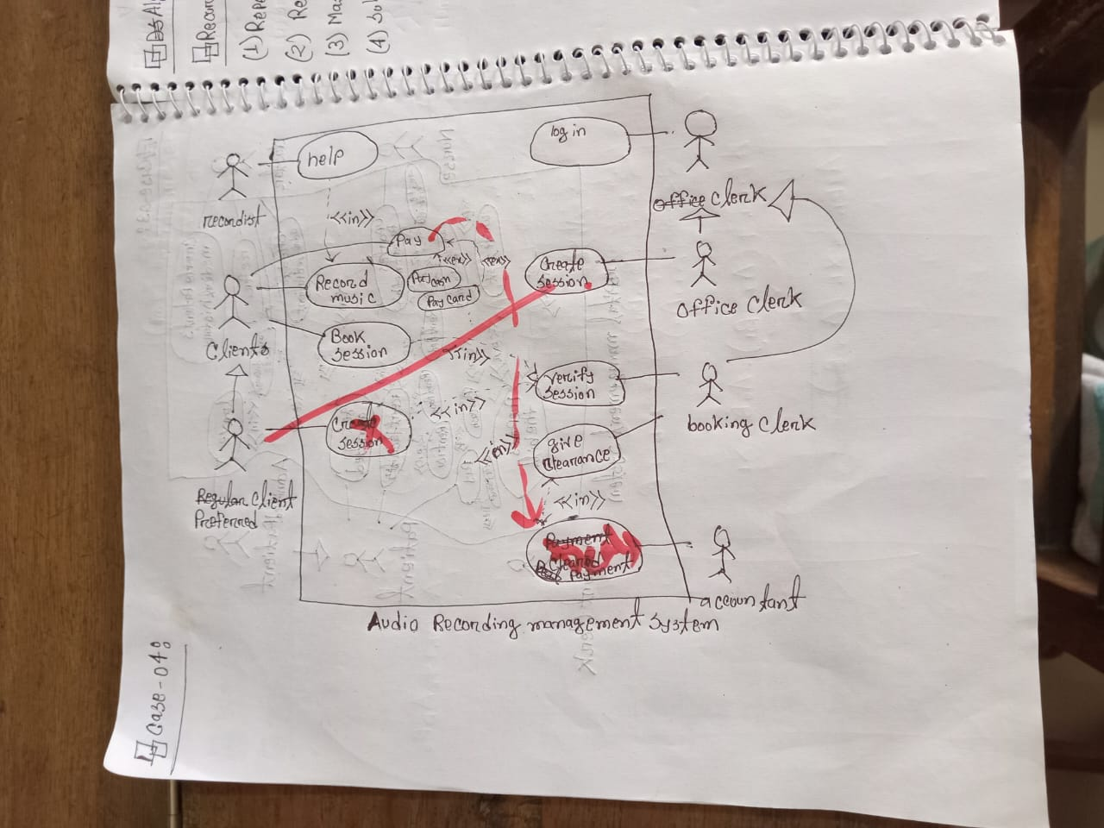

Case 5:

Users can create an account in an online auction system. They browse for products after logging in to the system. A seller places a product for auction and sets the minimum bid amount. He also sets a bidding time for the product. Buyers can bid for the product. After placing the bid for the first time, a buyer can change his bid amount anytime. The seller can also change the minimum bidding amount. At the end of the bidding time, the system sends a notification to the seller with information of the highest bidder. The highest bidder pays either using card or Bkash. Once payment is completed, the seller sends the product via postal service.
